Care of the Earth
Handy Hints and Behaviours
Final Draft 02/03/2023

Christian Brothers of Oceania

Introduction
One of the Laudato Si’s goals is the “Adoption of Simple Lifestyles”, and this booklet includes a list of behaviours and handy hints that you can participate in at an individual level. It is through a combination of our own individual efforts, added to those of all other individuals where real change can occur.
The most recent chapter identified Care of the Earth as a key area of focus, so Brothers and staff are encouraged to assess their own behaviours and consider adding other behaviours to your everyday living that are applicable in both household and workplace settings.
Several behaviours and hints have been listed and align to many of the Laudato Si goals, and there may be many that you are already doing, or there may be some that you would consider participating in. There may also been some that are not applicable or able to be acted upon and that’s okay, as the intent of this resource is to identify options that may be applicable for someone and to encourage you to participate in something above what you are already doing.
It is well acknowledged that many Brothers and staff have been living sustainable lives for a long time and included here is not an exhaustive list of what can be done, but it is a simple checklist of possibilities to help you, as an individual, to support the goals of Laudato Si’ and our own progress with the goals of Laudato Si.

Chris Hill
Oceania Province

Waste Reduction

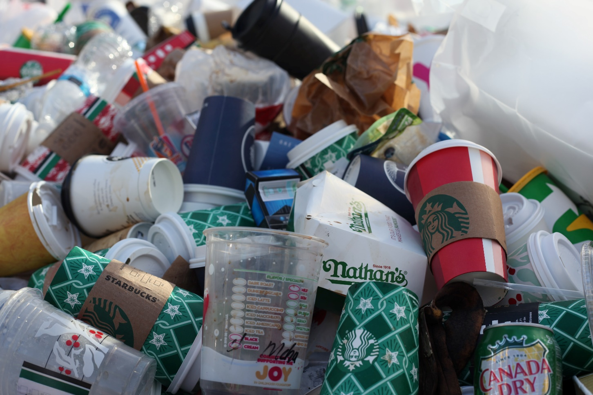

Hint No. | Waste | Already doing | Will do | N/A
47 | The 5 R’s - REFUSE – plastic bags, take your own reusable bags when shopping.
48 | The 5 R’s – REFUSE - Use bar soap, shampoo and stain removers that aren’t packaged in plastic.
49 | The 5 R’s - REFUSE – put a “no junk mail” sign on your letter box to discourage advertising material.
50 | The 5 R’s – REFUSE - Stop paper bank statements and pay your bills online or via your mobile device.
51 | The 5 R’s – REFUSE – take your own reusable containers to the shops
52 | The 5 R’s - REDUCE - paper consumption by printing on both sides.
53 | The 5 R’s - REDUCE - printing by only printing when necessary
54 | The 5 R’s – REDUCE – Bring your flask on train or car journeys to reduce plastic waste
55 | The 5 R’s – REDUCE - Don’t buy fruit and veggies wrapped in plastic.
56 | The 5 R’s – REDUCE - Buy a silicone oven try mat to replace baking paper.
57 | The 5 R’s – REUSE - Before throwing something out, consider if it can be recycled or used by someone else.
58 | The 5 R’s – REUSE - Share with friends—Share things like books, magazines, movies, games, and newspapers.
59 | The 5 R’s – REUSE - Donate unwanted goods to charity or to the recycle depots.
60 | The 5 R’s – REUSE - Bring your own ‘Sustainability Keep Cup’ when purchasing coffee and/or ordering hot drinks.
61 | The 5 R’s – RECYCLE - Use recycled or carbon neutral copy paper.
62 | The 5 R’s – RECYCLE - Separate recycling waste from general waste (if available in your area).
63 | The 5 R’s – RECYCLE – Use E-waste recycling programs when disposing of your electronics.
64 | The 5 R’s – ROT - Get into composting with a compost bin, and reduce your organic household waste by up to 40%. You can also hire a brown bin for cooked food waste.

