Handy Hints for Conserving Water
From the Christian Brothers of Oceania

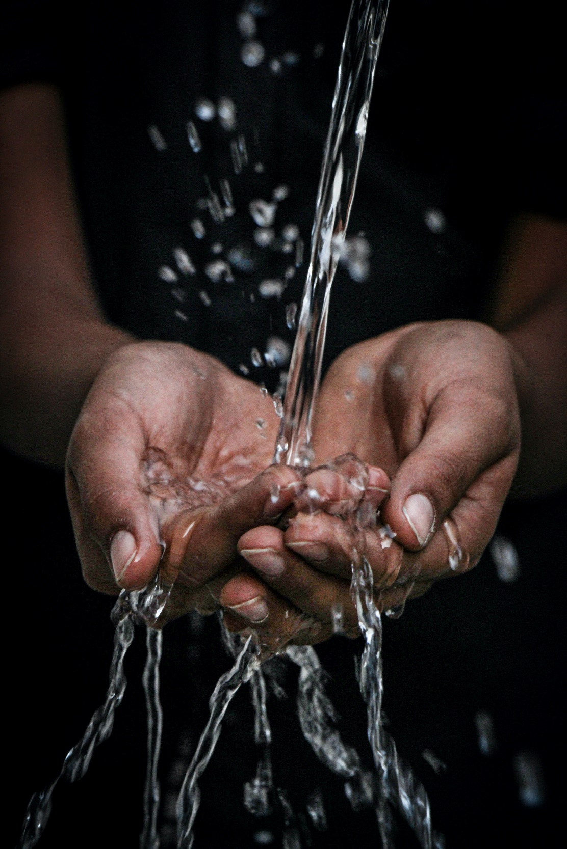

Hint No. | Water | Already Doing | Will do | N/A
17 | Use a refillable water bottle instead of purchasing bottles of  water.
18 | Report any water leaks to the property team or contact a  plumber so they can be fixed as soon as possible.
19 | Bathroom - Turn off water while brushing your teeth.
20 | Bathroom - Shorten your shower by a minute or two to save water.
21 | Bathroom - If your toilet does not have a dual flush option, fill one or more soft drink bottles with water and place them in the  cistern.
22 | Bathroom - While you wait for hot water, collect the running water, and use it to water plants.
23 | Bathroom - Consider installing a water efficient shower head.
24 | Garden - When watering your garden, only apply water as fast as the soil can absorb it, and water, if possible, in the evening.
25 | Garden - Plant trees and/or other vegetation to retain water on site.
26 | Garden - Consider Investigating if your property can accommodate and is suitable for a water butt.
27 | Garden - Ensure the soil is mulched, composted, and is kept in the best condition (with organics) to retain water so that less  watering is necessary.
28 | Garden-Cover Garden beds with mulch as this will reduce  evaporative water loss.
29 | Garden - Consider Investigating if your property can accommodate and is suitable for a water tank.
30 | Kitchen - Wash your fruits and vegetables in a basin of water instead of running water from the tap.
31 | Kitchen - Select the proper pan size for cooking. Large pans may  require more cooking water than necessary.
32 | Kitchen - Only use the dishwasher when it is fully loaded.
33 | Washing Machine - Adjust the water level of your washing machine if doing small loads.
34 | Washing Machine - Wash your clothes in lower temperatures.

